**Ex. No.:1D**

**Date: 17/02/2024**

**COLUMNAR TRANSPOSITION TECHNIQUES**

**Aim:**

To write a Python program to encrypt and decrypt a Plain Text using Columnar Transposition Techniques.

**Algorithm:**

1. The message is written out in rows of a fixed length and then read out again column by column and the columns are chosen in some scrambled order.
2. Width of the rows and the permutation of the columns are usually defined by a keyword,]
3. The permutation is defined by the alphabetical order of the letters.
4. Any spare spaces are filled with nulls or left blank or placed by a character.
5. Finally, the message is printed off in columns, in the order specified by the keyword.

**Program:**

**#Columnar Transposition Techniques**

import math

key = "HACK"

# Encryption

def encryptMessage(msg):

cipher = ""

# track key indices

k_indx = 0

msg_len = float(len(msg))

msg_lst = list(msg)

key_lst = sorted(list(key))

# calculate column of the matrix

col = len(key)

# calculate maximum row of the matrix

row = int(math.ceil(msg_len / col))

# add the padding character '_' in empty

# the empty cell of the matix

fill_null = int((row * col) - msg_len)

msg_lst.extend('_' * fill_null)

# create Matrix and insert message and

# padding characters row-wise

matrix = [msg_lst[i: i + col]

for i in range(0, len(msg_lst), col)]

# read matrix column-wise using key

for _ in range(col):

curr_idx = key.index(key_lst[k_indx])

cipher += ''.join([row[curr_idx] for row in matrix])

k_indx += 1

return cipher

# Decryption

def decryptMessage(cipher):

msg = ""

# track key indices

k_indx = 0

# track msg indices

msg_indx = 0

msg_len = float(len(cipher))

msg_lst = list(cipher)

# calculate column of the matrix

col = len(key)

# calculate maximum row of the matrix

row = int(math.ceil(msg_len / col))

# convert key into list and sort

# alphabetically so we can access

# each character by its alphabetical position.

key_lst = sorted(list(key))

# create an empty matrix to

# store deciphered message

dec_cipher = []

for _ in range(row):

dec_cipher += [[None] * col]

# Arrange the matrix column wise according

# to permutation order by adding into new matrix

for _ in range(col):

curr_idx = key.index(key_lst[k_indx])

for j in range(row):

dec_cipher[j][curr_idx] = msg_lst[msg_indx]

msg_indx += 1

k_indx += 1

# convert decrypted msg matrix into a string

try:

msg = ''.join(sum(dec_cipher, []))

except TypeError:

raise TypeError("This program cannot","handle repeating words.")

null_count = msg.count('_')

if null_count > 0:

return msg[: -null_count]

return msg

# Driver Code

msg = input("Enter message:")

cipher = encryptMessage(msg)

print("Encrypted Message: {}".format(cipher))

print("Decryped Message: {}".format(decryptMessage(cipher)))

**Output:**

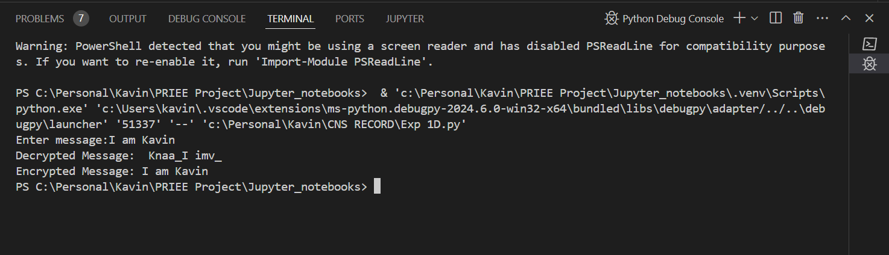

**Result:**

Hence, Columnar Transposition Techniques has been implemented successfully.